Project 1

I am planning to make a 2d side scroller platformer game, where the player will have to traverse from left to right in order to finish the game. There will be a few obstacles in the level to make it more challenging for the player. I will aim to animate the player and possible attacks.

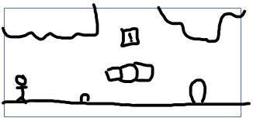

If we take a look at the elegantly drawn picture above, we see a stick ma which will be the player, some breakable blocks possibly holding loot and 2 kinds of enemies (the little blobby guys) being able to finish a level to this standard is what I believe I can do.

Player / animation

The player will have idle, attacking and movement animations throughout the game I have already chosen a sprite. Attack Idle Movement

Music controls

Intro (track1) Keyboard wasd

Gameplay (track2)

Game over (track3)

Milestones

Get background walk animation and movement working in week1

Get attack and idle working and start to implement enemies with basic platforms week2

Work on enemy mechanics and animations possible loot system too week3

Schedule:

|  |  |  |
| --- | --- | --- |
| ***Task*** | ***Estimated hrs*** | ***Actual hrs*** |
| Spec | 0.5 | 0.25 |
| Design | 0.75 | 0.5 |
| Implement | 5 | 6+ |
| Debug and test | 1 | 2 |
| slack | 1 | 3+ |
| ***Total*** | 8.25 | 11.75+ |

Pseudocode for walk and walk anim

If getkey d

Walk right

Play walk anim

If getkey a

Flip y axis

Walk right

Play walk anim

If getkey r

Attack anim

Else

Idle anim